CHAPTER FOUR
ANALYSIS AND RESULTS
4.1 Introduction
This chapter presents the design and implementation of the proposed School Learning Management System (LMS). The chapter describes the system architecture, database design, module design, user interface design, implementation technologies, and testing procedures employed during the development of the system. The design was guided by the requirements identified in Chapter Three and aimed at providing a scalable, secure, and user-friendly platform for managing academic activities within educational institutions.
The proposed system was developed using an API-first architecture that separates the frontend from the backend, thereby improving maintainability, scalability, and future integration with mobile applications and third-party services.

4.2 Design of the Proposed System
The proposed School Learning Management System was designed to automate academic and administrative processes within educational institutions. The system integrates students, teachers, parents, and administrators into a unified platform that supports teaching, learning, communication, assessment, attendance management, and academic reporting.
The design objectives of the proposed system include:
- Providing a centralised academic management platform.
- Improving communication among stakeholders.
- Enhancing accessibility to educational resources.
- Supporting online and blended learning environments.
- Automating assessment and grading processes.
- Generating real-time academic reports.
- Ensuring data security and user accountability.
The system adopts a modular structure to facilitate maintenance, scalability, and future upgrades.

4.3 System Architecture
The proposed LMS adopts a three-tier architecture consisting of the Presentation Layer, Application Layer, and Data Layer.
4.3.1 Presentation Layer
The Presentation Layer provides the user interface through which users interact with the system.
The layer supports:
- Administrator Dashboard
- Teacher Dashboard
- Student Dashboard
- Parent Portal
Technologies used include:
- HTML5
- CSS3
- JavaScript
- Bootstrap
Responsibilities include:
- Data presentation
- Form validation
- User interaction
- API communication

4.3.2 Application Layer
The Application Layer contains the business logic and RESTful API services responsible for processing user requests.
Technologies used include:
- PHP
- REST API
- JSON
Functions include:
- Authentication
- Authorisation
- Course Management
- Assignment Processing
- Assessment Management
- Report Generation
- Notification Services

4.3.3 Data Layer
The Data Layer stores all academic and administrative information.
Technology used:
- MySQL Database Management System
Responsibilities include:
- Data storage
- Data retrieval
- Data consistency
- Backup and recovery

Figure 4.1: System Architecture Diagram
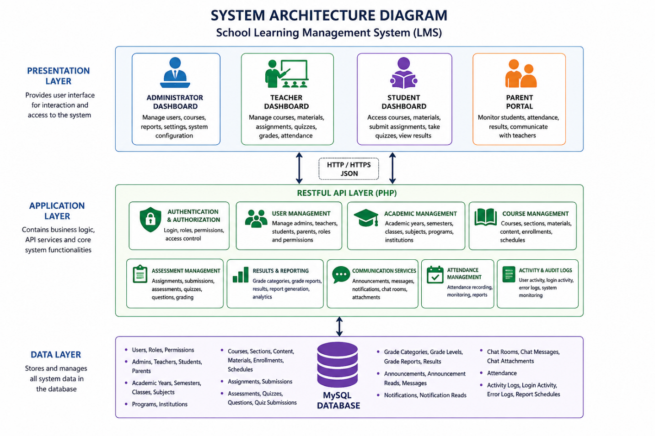
Explanation
The frontend communicates with backend services through REST APIs. The API layer processes requests and performs business operations before interacting with the MySQL database. This architecture improves maintainability, security, and scalability.

4.4 Use Case Design
The Use Case Diagram illustrates the interactions between the users of the Learning Management System and the system itself. It identifies the primary actors and the services available to each actor. The system supports four main actors: Administrator, Teacher, Student, and Parent.
The Use Case Diagram helps in understanding the functional requirements of the system and demonstrates how users interact with various system modules.

Explanation of the Use Case Diagram
The Use Case Diagram illustrates the major interactions between system users and the Learning Management System.
Administrator
The Administrator is responsible for overall system management. The administrator can:
- Manage users.
- Assign roles and permissions.
- Create and manage courses.
- Configure academic years and semesters.
- Generate reports.
- Publish announcements.
Teacher
Teachers are responsible for academic activities. They can:
- Manage assigned courses.
- Upload learning materials.
- Create assignments.
- Create quizzes and assessments.
- Record attendance
- Grade student submissions.
- View academic reports.
Student
Students interact with the learning platform by:
- Accessing enrolled courses
- Downloading learning materials
- Submitting assignments
- Taking quizzes
- Viewing results
- Checking attendance records
- Receiving notifications
Parent
Parents can monitor the academic progress of their children by:
- Viewing results
- Monitoring attendance
- Receiving announcements and notifications
- Communicating with teachers

4.4 Database Design
The database was designed using relational database principles to ensure efficient storage, retrieval, and management of academic information.
The database consists of seventy-five (75) interconnected tables grouped into several modules.
Major Database Modules
User Management
- users
- roles
- permissions
- user_roles
- admins
- teachers
- students
- parents
Academic Management
- academic_years
- semesters
- classes
- subjects
- programs
- institutions
Learning Management
- course_sections
- course_content
- course_content_order
- course_materials
- course_enrollments
Assessment Management
- assignments
- assignment_submissions
- assessments
- quizzes
- quiz_questions
- quiz_submissions
Results Processing
- grade_reports
- grade_report_details.
- results
- grade_categories
- grade_levels
Communication
- announcements
- messages
- notifications
- chat_rooms
- chat_messages
Attendance
- attendance
Audit and Monitoring
- login_activity
- user_activity
- admin_activity
- teacher_activity
- student_activity
The database was normalised to Third Normal Form (3NF) to minimise redundancy and improve data integrity.

4.5 Entity Relationship Diagram (ERD)
Figure 4.3: High-Level Entity Relationship Diagram
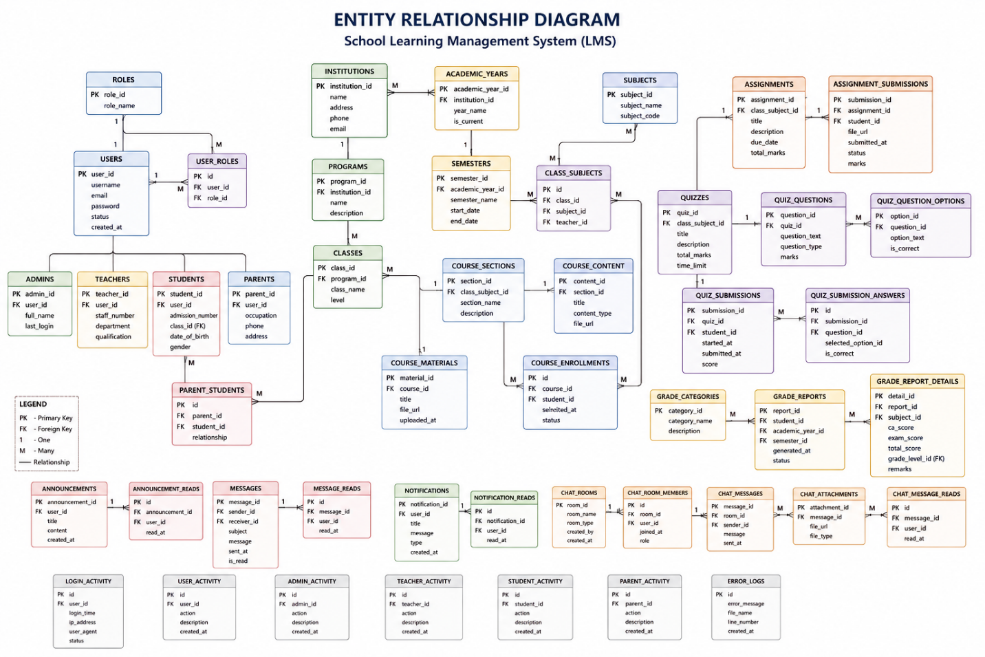

Explanation
The ERD illustrates the relationships between users, courses, assessments, learning materials, and reporting components. Teachers manage courses and assessments while students enrol in courses and submit academic work. Results generated from assessments contribute to grade reports and performance analysis.

4.6 Data Dictionary
Table 4.1: Users Table
Field Name | Data Type | Description
user_id | INT | Unique user identifier
username | VARCHAR(100) | Login username
email | VARCHAR(150) | User email
password | VARCHAR(255) | Encrypted password
role_id | INT | Assigned role
created_at | DATETIME | Account creation date

Table 4.2: Students Table
Field Name | Data Type | Description
student_id | INT | Student identifier
user_id | INT | Linked user account
admission_number | VARCHAR(50) | Student number
class_id | INT | Assigned class
parent_id | INT | Linked parent

Table 4.3: Teachers Table
Field Name | Data Type | Description
teacher_id | INT | Teacher identifier
user_id | INT | Linked user account
staff_number | VARCHAR(50) | Staff number
department | VARCHAR(100) | Department

Table 4.4: Courses Table
Field Name | Data Type | Description
course_id | INT | Course identifier
teacher_id | INT | Assigned teacher
course_name | VARCHAR(150) | Course title
description | TEXT | Course description

4.7 Input Design
Input design was developed to facilitate accurate and efficient data entry while minimising user errors.
Administrator Inputs
- User Registration Form
- Teacher Registration Form
- Student Registration Form
- Course Creation Form
- Academic Year Setup Form
Teacher Inputs
- Material Upload Form
- Assignment Creation Form
- Quiz Creation Form
- Attendance Entry Form
- Grade Entry Form
Student Inputs
- Assignment Submission Form
- Profile Update Form
- Course Registration Form
Input validation mechanisms include:
- Required field validation.
- Email validation
- Password validation
- File upload restrictions.
- Duplicate record checking

4.8 Output Design
The system produces several outputs that assist decision-making and academic management.
Administrative Outputs
- User Reports
- Academic Reports
- Institution Statistics
- System Activity Reports
Teacher Outputs
- Attendance Reports
- Student Performance Reports
- Assignment Reports
- Assessment Reports
Student Outputs
- Results Reports
- Assignment Status Reports
- Attendance Reports
- Academic Progress Reports

4.9 User Interface Design
The system provides separate interfaces for each category of user.
Administrator Dashboard
Functions include:
- User Management
- Course Management
- Academic Settings
- Reports
- System Configuration
Teacher Dashboard
Functions include:
- Course Management
- Material Upload
- Assignment Management
- Attendance Tracking
- Grade Recording
Student Dashboard
Functions include:
- Course Access
- Material Downloads
- Assignment Submission
- Results Viewing
- Notifications
Parent Dashboard
Functions include:
- Student Monitoring
- Attendance Viewing
- Results Monitoring
- Communication with Teachers

4.10 System Modules Implemented
Authentication and Security Module
Functions:
- Login
- Logout
- Password Management
- Role-Based Access Control
User Management Module
Functions:
- User Registration
- User Profile Management
- Role Assignment
Academic Management Module
Functions:
- Academic Year Management
- Semester Management
- Class Management
Learning Management Module
Functions:
- Course Creation
- Content Management
- Material Distribution
Assessment Module
Functions:
- Assignment Creation
- Quiz Management
- Assessment Management
Results Processing Module
Functions:
- Grade Computation
- Result Generation
- Academic Reporting
Communication Module
Functions:
- Messaging
- Notifications
- Announcements
- Chat System
Attendance Module
Functions:
- Attendance Recording
- Attendance Monitoring

4.11 Implementation Tools and Technologies
The following technologies were used during implementation:
Backend Technologies
- PHP 8
- RESTful API
- JSON
Frontend Technologies
- HTML5
- CSS3
- JavaScript
- Bootstrap 5
Database
- MySQL
Development Tools
- Visual Studio Code
- Git
- GitHub
- Postman
Server Environment
- Apache Server
- XAMPP

4.12 System Testing
System testing was conducted to verify that all modules functioned according to the specified requirements.
Testing methods employed include:
- Unit Testing
- Integration Testing
- System Testing
- User Acceptance Testing

4.13 Test Cases
Table 4.5: Sample Test Cases
Test Case | Expected Result | Status
User Login | User successfully authenticated | Pass
Create Course | Course saved successfully | Pass
Upload Material | Material uploaded successfully | Pass
Create Assignment | Assignment created successfully | Pass
Submit Assignment | Submission recorded successfully | Pass
Record Attendance | Attendance saved successfully | Pass
Generate Result | Result generated successfully | Pass
Send Message | Message delivered successfully | Pass

4.14 Summary
This chapter presented the design and implementation of the proposed School Learning Management System. The chapter discussed the system architecture, database design, entity relationships, user interfaces, implementation technologies, system modules, and testing procedures. The system was successfully developed using an API-first architecture and a relational database structure consisting of seventy-five interconnected tables. The implementation provides comprehensive support for academic administration, learning management, communication, assessment, attendance tracking, and reporting activities within educational institutions.

